GIFT AID DECLARATION

Boost your donation by 25p of Gift Aid for every £1 you donate

We reclaim Gift Aid from the tax you pay for the current tax year (your address is needed to identify you as a current UK taxpayer).

Name of Charity: The Friends of St Winnow Church

I am a UK taxpayer and understand that if I pay less Income Tax and/or Capital Gains Tax than the amount of Gift Aid claimed on all my donations in that tax year it is my responsibility to pay any difference.

Title: _________ Forename: __________________________________
Surname: ___________________________________________________
Address: ____________________________________________________
___________________________________________________________
Postcode: ________________ Date: ___________________________

Please notify the charity if you:
- want to cancel this declaration
- change your name or home address
- no longer pay sufficient tax on your income and/or capital gains
If you pay Income Tax at the higher or additional rate and want to receive the additional tax relief due to you, you must include all your Gift Aid donations on your Self-Assessment tax return or ask HM Revenue and Customs to adjust your tax code.

THE FRIENDS OF
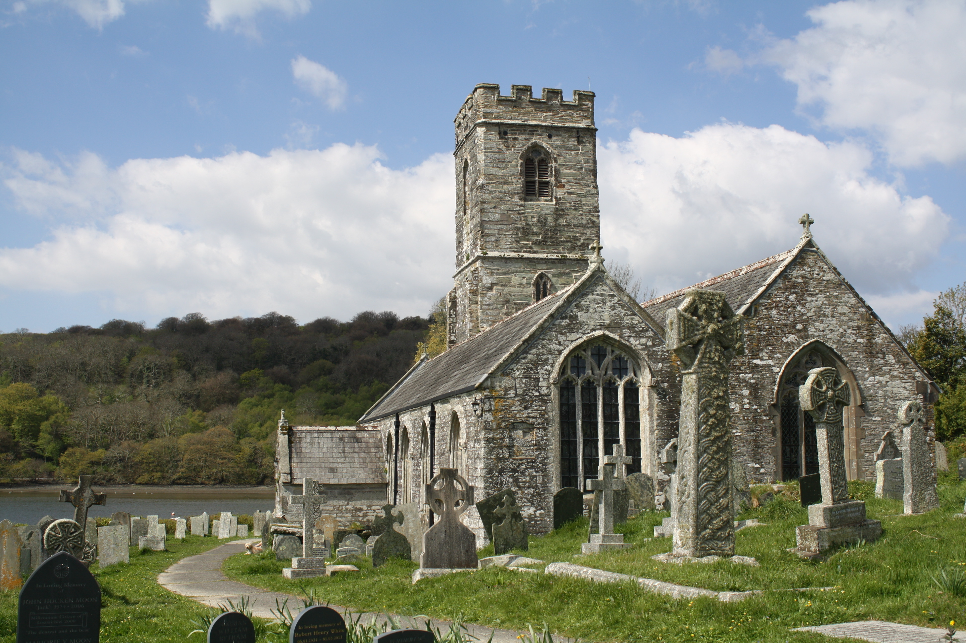
ST WINNOW CHURCH

St Winnow is a spectacular Grade I listed church nestled on the banks of the River Fowey. Built on the site of a Celtic oratory, the church has remnants of a Norman building from the 12th century. Renovations in the 15th century saw the enlargement of the church and the addition of beautiful carved bench ends, rood screen and a perpendicular granite font with carvings of angels bearing heraldic shields. The Lady Chapel window of this period is an outstanding example of medieval glasswork.

The ‘Friends’ was founded in 2002 to support the Church. In that time we have funded new heating, a toilet, pew cushions, a display unit, restoration of some of the medieval stained glass window, a hearing loop and sound system, a vestry screen and in 2016 a major donation towards the restoration of the bell tower and new bells. In 2018 The Friends widened its remit to also fund repairs of St Winnow’s Grade II chapel of ease at St Nectan.

We are a small resident congregation and receive no State aid, however we are blessed with Friends around the world that have visited St Winnow and have made a connection with the church and her people.
APPLICATION & STANDING ORDER FORM

Instruction to your Bank or Building Society:

Name of bank/building society: _______________________________
Address: ________________________________________________
__________________________________ Postcode: ______________
Name(s) of account holder(s): ________________________________
Account Number:
Branch Sort Code:

Please pay The Friends of St Winnow Church the sum of £_________ annually, starting on _______ _____________ (insert date)
Sort Code: 30-97-28 Account No: 02062516

Please return this form to Friends of St Winnow NOT your bank

Please complete and return this form to:
The Secretary - Friends of St Winnow Church
Trebant
Penpol
Lostwithiel PL22 0NG

Personal Details:
Title: _____ Forename: __________ Surname: _________________
Address: _________________________________________________
_______________________________ Postcode: ________________
Tel: _______________ Email: ______________________________
We will not share any of your details with third party organisations

Signature(s): ______________________________
_________________________________________
Date: _____/_____/_____

I/We would like to make an annual subscription of £10 per person, renewable each year on this due date (please tick the box)
❑ £10  £15  £20  other £_______
To comply with Data Protection Regulations we need your permission to communicate with you. We respect your privacy; your details will only be used by the Friends of St Winnow Church – we never give your information to any third party.

We would like to keep you informed with our news, appeals activities and events. Please tick the boxes below to agree to this.
By email:  By post: 
Thank you for your donation and we look forward to welcoming you as a Friend of this beautiful and historic church.

Registered Charity No 1098611

